Twenty Second Sunday After Pentecost – October 20th, 2024

Introduction to the Day

Today’s gospel starts with disciples obsessing over who will be closest to Jesus, leading to Jesus teaching his followers about God’s take on importance and power. Here Jesus makes it explicit that the reversal of values in God’s community is a direct challenge to the values of the dominant culture, where wielding power over others is what makes you great. When we pray “your kingdom come” we are praying for an end to tyranny and oppression. We pray this gathered around the cross, a sign of great shame transformed to be the sign of great honor and service.

**Greeting – The grace of our Lord Jesus Christ, the love of God, and the communion of the Holy Spirit be with you all.**

And also with you.

**Welcome**

**Confession and Forgiveness**

Blessed be the holy Trinity, ☩ one God,

who forgives all our sin,

whose mercy endures forever.

**Amen.**

Let us confess our sin and come to God for healing.

*Silence is kept for reflection.*

Gracious God,

**have mercy on us.**

**We confess that we have honored you with our lips, but have harmed our neighbors with our tongues.**

**The cravings at war within us cause conflicts and disputes.**

**In our desire to be first we make distinctions among ourselves.**

**We place the needs of the poor and the suffering last.**

**In your great mercy, forgive us our sins.**

**Draw near to us with grace in time of need,**

**and turn us to follow in the way of Jesus Christ,**

**our Savior and Lord.**

**Amen.**

God promises to forgive our iniquity

and to remember our sin no more.

By grace you have been saved.

In the name of ☩ Jesus Christ,

the source of eternal healing,

your sins are forgiven.

**Amen.**

**Gathering Hymn “Rise, Shine, You People” #665**

**Prayer of the Day**

Gracious God, we thank you for the community that is Lutheran Church of the Good Shepherd. We are grateful for the lives impacted, relationships built, and the mission we share in the neighborhood and larger community.

We turn our hearts and minds to the future, knowing that your work is not done here. Enlighten and enliven us to come together in confidence, courage, and hope. Fill us with your life-giving love. Give us generous hearts to commit fully to the work of the **“Building Together for Generations to Come”** Capital Campaign.

Stir in us a desire to contribute to a creative and faithful legacy. As we go forward, bless this campaign to be a blessing to others. May all that we do lead others into a relationship with you and bring honor and glory to your name. AMEN

**Capital Campaign Verse - Colossians 2:6-7**

As you therefore have received Christ Jesus as Lord, continue to walk in him, rooted and built up in him,

established in the faith, just as you were taught, abounding in thanksgiving.

**Reading - Psalm 90:12-17**

9 Because you have made the Lord your refuge, and the Most High your habitation,

**10 no evil will befall you, nor shall affliction come near your dwelling.**

11 For God will give the angels charge over you, to guard you in all your ways.

**12 Upon their hands they will bear you up, lest you strike your foot against a stone.**

13 You will tread upon the lion cub and viper; you will trample down the lion and the serpent.

**14 I will deliver those who cling to me; I will uphold them, because they know my name.**

15 They will call me, and I will answer them; I will be with them in trouble; I will rescue and honor them.

**16 With long life will I satisfy them, and show them my salvation.**

The word of the Lord

**Thanks be to God.**

**Gospel – Mark 10:35-45**

35James and John, the sons of Zebedee, came forward to him and said to him, “Teacher, we want you to do for us whatever we ask of you.” 36And he said to them, “What is it you want me to do for you?” 37And they said to him, “Grant us to sit, one at your right hand and one at your left, in your glory.” 38But Jesus said to them, “You do not know what you are asking. Are you able to drink the cup that I drink, or be baptized with the baptism that I am baptized with?” 39They replied, “We are able.” Then Jesus said to them, “The cup that I drink you will drink; and with the baptism with which I am baptized, you will be baptized; 40but to sit at my right hand or at my left is not mine to grant, but it is for those for whom it has been prepared.”

 41When the ten heard this, they began to be angry with James and John. 42So Jesus called them and said to them, “You know that among the Gentiles those whom they recognize as their rulers lord it over them, and their great ones are tyrants over them. 43But it is not so among you; but whoever wishes to become great among you must be your servant, 44and whoever wishes to be first among you must be slave of all. 45For the Son of Man came not to be served but to serve, and to give his life a ransom for many.”

The Gospel of Our Lord.

Praise to you, O Chri**st.**

**Sermon**

People of God, grace to you and peace from God, and from our Lord and Savior Jesus Christ. AMEN

“Grant us to sit, one on your right, and one on your left, in your glory.”

Jesus has just, for now the third and final time, told the disciples how it is that he is going to die. He will be betrayed. He will be beaten, mocked, and brutally killed. He has told them this before. And, each time that he has, the disciples are befuddled and from that befuddlement get a valuable lesson in what it means to be a disciple of Jesus Christ.

The first time: If any want to be my followers, let them deny themselves, take up their cross, and follow me. To truly be a disciple is to let go of all that holds us back from truly and fully serving Jesus.

The second time: Whoever wants to be first must be last of all AND servant of all. Waiting our turn is the easy part, but serving others in the waiting is what it truly means to be a Jesus follower.

In both of these instances we really start to wonder if they disciples are paying attention at all. We learn that their idea of being Jesus followers will have them living kingly lives with palaces and servants and it will be good. Jesus continually reminds them that it will be much the opposite. And they struggle with that. But, they seem to coming around. And, we see it in their question.

Their response to the third time Jesus tells them of his pending death. “Then tell us, which one of us will sit on your right and on your left…in your glory.”

They know it is coming, yet they still don’t grasp it. They know he is to die but with it will come glory, and, as his followers that glory will come to them as well. There is still hope for them and their glorious life as Jesus followers. But we know better.

Throughout all of this discourse, this whole ongoing process of Jesus telling them about his pending death, they are looking out for themselves. Continually Jesus tells them that to be a Jesus follower is to be for other people, but not *just* other people, but the *others* that the world would much rather forget.

Jesus never wavers on this. Jesus is steadfast in his word that began with Mary’s song when she learned of her pregnancy, continued with the testimony of John at the Jordan, and throughout his ministry telling people not to tell anyone of what they have experienced…for Jesus, it is never about the glory. For Jesus, it is always about others.

And, Jesus never misses an opportunity to show them what he means, not just with words, but how this whole story plays out. He asks them, “are you able to drink from the cup that I will drink, and be baptized with baptism with which I will be baptized?” And, they are certain. But do they know what it is that he is talking about?

Jesus is referring here, again, to the suffering and death that he will endure. That is his glory. Suffering and death on a cross is the glory that our Lord and Savior will experience. Not some castle. Not servants. Not lording it over others. But, death on a cross.

And, when we look ahead to how it is that this death will play out, we see who it is that is on his left and his right, in his glory. In true Jesus fashion it is people that the world would rather cast aside. Jesus on the cross will be flanked not by those who have rode his coattails throughout his ministry, but by those whom he has told people that they are to care for as Jesus followers.

AND, he has the audacity from that cross to tell them that yes, even they, will be with him that day in paradise.

Jesus again, and again, and again, points to the other. Being asked by two of his closest disciples and friends who it is that will be on his left and on his right in his glory, reminds them that those spots are for the least, the last, and the lost.

That is the glory of Jesus Christ. That is what he came to do and be. To save the least, the last, and the lost. That doesn’t mean that if that isn’t how you identify that you aren’t included. Instead, it assures you that in those moments when you do feel least, last, or lost, that God in Jesus Christ is right there beside you. A savior who came not to be served, but to serve, and give his life a ransom for many.

Thanks be to God.

AMEN

**Hymn of the Day “Lord, Whose Love in Humble Service” #712 vss 1, 3**

**Apostle’s Creed**

**Prayers**

Challenged by God’s Word in Christ, let us pray for the church, the world, and the whole creation.

*A brief silence.*

Holy One, we give thanks for all servant leaders of the church. Bless bishops, pastors, and deacons (*local leaders may be named*) with humble wisdom and ground them in your love. God of grace,

**hear our prayer.**

Creative One, we give thanks for the delicate balance of the natural world. Kindle in us a spirit of caring strength in the preservation of habitats, food availability, and centers of refuge, that all wildlife may thrive. God of grace,

**hear our prayer.**

Empowering One, fill the leaders of governments with a spirit of service that prioritizes those on the margins due to job loss, underemployment, unsafe working conditions, and immigration status. May economic equity be achieved for all people. God of grace,

**hear our prayer.**

Restoring One, send your angels to watch over, rescue, and protect those who are injured or ill. Nurse those who suffer hardship, disease, injury, or difficulty with your comfort and peace. We pray especially for Becky, Dawn, *Grady and Jace, Matt, Clarice, Steve, Kathy, Val, Cherri, Peggy, John, Judy, Keith and JoJo, Bob and Joanne, Frank and Heather, Bob and Sonja, Bill and Betty, Tom and Kay, Sherm and Mary, Dan and Sharon, Roger and MaryLee.* (*especially*). God of grace,

**hear our prayer.**

Abiding One, you call pastors to shepherd the congregation toward faithful living as servants and followers of Jesus. Inspire all ordained ministers and seminarians (*local clergy or seminarians may be named*) to ministry that challenges, engages, and comforts those in their care. God of grace,

**hear our prayer.**

Saving One, we give thanks for the disciples James and John and all saints who have faithfully served you. We rejoice in a promised place at the feast of victory that we receive by your grace alone. God of grace,

**hear our prayer.**

Into your hands, O God, we commend all for whom we pray, trusting in the saving grace you freely give, both now and forever.

**Amen.**

**Peace**

**Offering**

**Offertory Prayer**

Blessed are you, O God,

source of every gift of your creation.

By these gifts and with our lives,

help us to serve one another and all in need,

through Jesus Christ, our Savior and Lord.

**Amen.**

**Sacrament of Holy Communion**

**Lord’s Prayer**

Jesus welcomes you to this table.

Come, here is your God.

**Post Communion Prayer**

Holy God,

you have welcomed us to this meal

and fed us with dignity at your table.

Send us now to welcome others

and to be at peace with one another,

through Jesus Christ our Lord.

**Amen.**

**Sending**

Go in peace. Follow Jesus!

**Okay! We will! Thanks be to God.**

And all of Good Shepherd said,

**“AMEN”**

**Sending Hymn “We Are Called” #720**

**Blessing**

God all mighty,

God most merciful

☩ bless you, keep you,

and give you peace.

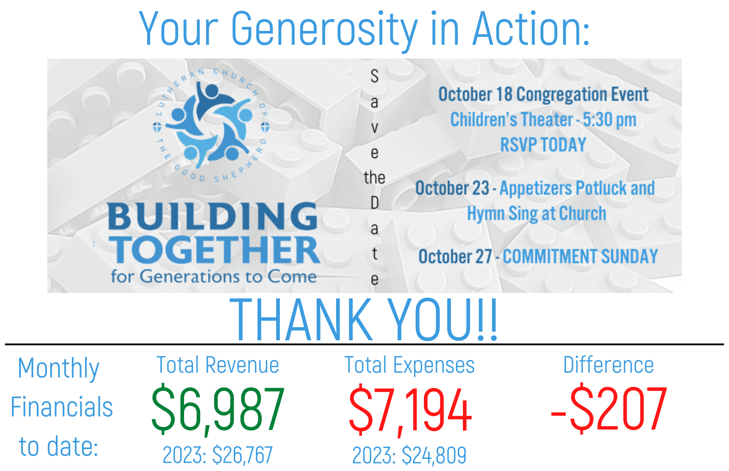**Amen.**



