Reformation Sunday – October 27th, 2024

Introduction to the Day

Rooted in the past and growing into the future, the church must always be reformed in order to live out the love of Christ in an ever-changing world. We celebrate the good news of God’s grace, that Jesus Christ sets us free every day to do this life-transforming work. Trusting in the freedom given to us in baptism, we pray for the church, that Christians will unite more fully in worship and mission.

**Greeting – The grace of our Lord Jesus Christ, the love of God, and the communion of the Holy Spirit be with you all.**

And also with you.

**Welcome**

**Confession and Forgiveness**

Blessed be the holy Trinity, ☩ one God,

who forgives all our sin,

whose mercy endures forever.

**Amen.**

Let us confess our sin and come to God for healing.

*Silence is kept for reflection.*

Gracious God,

**have mercy on us.**

**We confess that we have honored you with our lips, but have harmed our neighbors with our tongues.**

**The cravings at war within us cause conflicts and disputes.**

**In our desire to be first we make distinctions among ourselves.**

**We place the needs of the poor and the suffering last.**

**In your great mercy, forgive us our sins.**

**Draw near to us with grace in time of need,**

**and turn us to follow in the way of Jesus Christ,**

**our Savior and Lord.**

**Amen.**

God promises to forgive our iniquity

and to remember our sin no more.

By grace you have been saved.

In the name of ☩ Jesus Christ,

the source of eternal healing,

your sins are forgiven.

**Amen.**

**Gathering Hymn “All are Welcome” #641**

**Prayer of the Day**

Gracious God, we thank you for the community that is Lutheran Church of the Good Shepherd. We are grateful for the lives impacted, relationships built, and the mission we share in the neighborhood and larger community.

We turn our hearts and minds to the future, knowing that your work is not done here. Enlighten and enliven us to come together in confidence, courage, and hope. Fill us with your life-giving love. Give us generous hearts to commit fully to the work of the **“Building Together for Generations to Come”** Capital Campaign.

Stir in us a desire to contribute to a creative and faithful legacy. As we go forward, bless this campaign to be a blessing to others. May all that we do lead others into a relationship with you and bring honor and glory to your name. AMEN

**Capital Campaign Verse - Colossians 2:6-7**

As you therefore have received Christ Jesus as Lord, continue to walk in him, rooted and built up in him,

established in the faith, just as you were taught, abounding in thanksgiving.

The word of the Lord

**Thanks be to God**

**Reading - Romans 3:19-28**

19 Now we know that whatever the law says, it speaks to those who are under the law, so that every mouth may be silenced, and the whole world may be held accountable to God. 20 For “no human being will be justified in his sight” by deeds prescribed by the law, for through the law comes the knowledge of sin.

  21 But now, apart from law, the righteousness of God has been disclosed, and is attested by the law and the prophets, 22 the righteousness of God through faith in Jesus Christ for all who believe. For there is no distinction, 23 since all have sinned and fall short of the glory of God; 24 they are now justified by his grace as a gift, through the redemption that is in Christ Jesus, 25 whom God put forward as a sacrifice of atonement by his blood, effective through faith. He did this to show his righteousness, because in his divine forbearance he had passed over the sins previously committed; 26 it was to prove at the present time that he himself is righteous and that he justifies the one who has faith in Jesus.

  27 Then what becomes of boasting? It is excluded. By what law? By that of works? No, but by the law of faith. 28 For we hold that a person is justified by faith apart from works prescribed by the law.

The word of the Lord

**Thanks be to God.**

**Gospel – Mark 10:36-42**

35James and John, the sons of Zebedee, came forward to him and said to him, “Teacher, we want you to do for us whatever we ask of you.” 36And he said to them, “What is it you want me to do for you?” 37And they said to him, “Grant us to sit, one at your right hand and one at your left, in your glory.” 38But Jesus said to them, “You do not know what you are asking. Are you able to drink the cup that I drink, or be baptized with the baptism that I am baptized with?” 39They replied, “We are able.” Then Jesus said to them, “The cup that I drink you will drink; and with the baptism with which I am baptized, you will be baptized; 40but to sit at my right hand or at my left is not mine to grant, but it is for those for whom it has been prepared.”

 41When the ten heard this, they began to be angry with James and John. 42So Jesus called them and said to them, “You know that among the Gentiles those whom they recognize as their rulers lord it over them, and their great ones are tyrants over them. 43But it is not so among you; but whoever wishes to become great among you must be your servant, 44and whoever wishes to be first among you must be slave of all. 45For the Son of Man came not to be served but to serve, and to give his life a ransom for many.”

The Gospel of Our Lord.

Praise to you, O Chri**st.**

**Sermon**

People of God, grace to you and peace from God, and from our Lord and Savior Jesus Christ. AMEN

For the last six weeks in worship we have read together our Building Together for Generations to Come Campaign scripture and prayed together our campaign prayer.

For the last six weeks we have read together Pauls words, written from jail, to the church in Collossae, imploring the church to continue to walk in Christ, to remain rooted in Christ. Paul reminds them they have been built up in Christ having been established in the faith, for that is what they were taught. And, in their life together they are to abound in thanksgiving.

This verse was chosen as a campaign verse as it captures life here at Good Shepherd. Going beyond the last six weeks, and looking at how we got to this point, the road was bumpy. Three years ago we found ourselves facing our own Reformation point as a congregation. With a financial picture that was none-to-pretty, we had difficult conversations about what the future might look like here.

Ultimately, it was declared that there is, indeed, a future here at Lutheran Church of the Good Shepherd. Your church leadership committed to a guided Stewardship Appeal to learn how it is that we talk about money, and how it is a gift from God that we are entrusted to Steward. But before we could do that, we needed to figure out how we were going to fund it. And people stepped up. We were now not only committed to a future in word, but also in our actions. And it worked.

We then found ourselves, having committed to a future, wondering what that future might look like. Your congregation leadership was asked the question: Why does Lutheran Church of the Good Shepherd exist? It was more difficult to answer than any in that room would care to admit. And understandably so. We were tired. Worn out. Wondering ourselves, how is God using me here at Lutheran Church of the Good Shepherd. IS God using me here at Lutheran Church of the Good Shepherd?

And, it was in that wondering and questioning that we committed to figuring out our WHY. What IS God’s future here at Lutheran Church of the Good Shepherd? And it was these questions that left us with a desire to do a Strategic Plan.

But, we needed the funds to make it happen. And, people stepped up. We were now not only committed to clarifying our future in our words, but in our actions as well. And, it worked.

And now we are here. All of these conversations, this 3 Year Reformation if you will has led us to this point. Gathered here today on Commitment Sunday of our Building Together for Generations to Come Capital Campaign with some feeling like we will never be successful. And maybe it won’t be. But, we gather with the words of Paul’s Letter to the Collossians fresh in our minds and tugging at our hearts.

We gather today affirming that Lutheran Church of the Good Shepherd will:

1. continue to walk in the Good News of Jesus Christ;
2. be rooted and built up in God’s Love in Jesus Christ,
3. remain established in the faith, just as you were taught - that this love is for all of God’s children,
4. abounding in thanksgiving for all that we have

I looked up the definition for the word abound and Merriam Webster had this to offer:

“to be present in large numbers or in great quantity: to be prevalent; to be copiously supplied”

We gather here today with a great quantity of gratitude for the generations that came before us here at Lutheran Church of the Good Shepherd. As we gather today the thanksgiving we have for those with us here and now is prevalent. As we think about the generations of people that will come to be Known - Seen - Loved by God because of the work of the Lutheran Church of the Good Shepherd and the ministries here, we do so with copious amounts of thanksgiving.

As we think about this campaign and the future of this church, God’s activity here, we do so with gratitude for the generosity that continues to show up here. Time and time again.

As I stand here in front of you today and this point in our own reformation, I give my thanks to you, and I give my thanks to God for the work that God continues to see needing to be done here for the community around us.

Thanks be to God.

AMEN

**Hymn of the Day “Seek ye First” WOV #783**

**Apostle’s Creed**

**Prayers**

Challenged by God’s Word in Christ, let us pray for the church, the world, and the whole creation.

*A brief silence.*

Lord of all, we give thanks for the whole church throughout the world. Open wide the paths toward unity between denominations so that all followers of Christ may join in shared worship and mission. God of grace,

**hear our prayer.**

Renewing God, as the dying leaves display their beauty, we are reminded that nature’s cycle of life includes and requires both life and death. Instill in your people a mission of preservation and appreciation for trees, animals, and waterways threatened by climate collapse. God of grace,

**hear our prayer.**

Gracious God, in the spirit of reformation we pray for all who cry out for relief from systemic oppression. May the hearts of those who occupy seats of power be reformed so that peace becomes the center of our life together. God of grace,

**hear our prayer.**

Comforting God, be with all who are sick, suffering, or grieving in our own community and beyond. We pray especially for Becky, Dawn, *Grady and Jace, Matt, Clarice, Steve, Kathy, Val, Cherri, Peggy, John, Judy, Keith and JoJo, Bob and Joanne, Frank and Heather, Bob and Sonja, Bill and Betty, Tom and Kay, Sherm and Mary, Dan and Sharon, Roger and MaryLee.* (*especially*) (*especially*). Surround them with the promise of your love, comfort, and grace that never ends. God of grace,

**hear our prayer.**

Divine Guide, continue to challenge this community to be ever reforming in our ministries and outreach efforts. Inspire creative ideas among us so that the communal, grace-filled word of God remains at the heart of our ministry. God of grace,

**hear our prayer.**

Almighty God, in Christ’s resurrection you ensure that though life be wrenched away, death cannot win the day. May the truth of your saving grace through faith sustain our hope for life in you. God of grace,

**hear our prayer.**

Into your hands, O God, we commend all for whom we pray, trusting in the saving grace you freely give, both now and forever.

**Amen.**

**Peace**

**Offering**

**Offertory Prayer**

Blessed are you, O God,

source of every gift of your creation.

By these gifts and with our lives,

help us to serve one another and all in need,

through Jesus Christ, our Savior and Lord.

**Amen.**

**Sacrament of Holy Communion**

**Lord’s Prayer**

Jesus welcomes you to this table.

Come, here is your God.

**Post Communion Prayer**

Holy God,

you have welcomed us to this meal

and fed us with dignity at your table.

Send us now to welcome others

and to be at peace with one another,

through Jesus Christ our Lord.

**Amen.**

**Sending**

Go in peace. Follow Jesus!

**Okay! We will! Thanks be to God.**

And all of Good Shepherd said,

**“AMEN”**

**Sending Hymn “This Little Light of Mine” #677**

**Blessing**

God all mighty,

God most merciful

☩ bless you, keep you,

and give you peace.

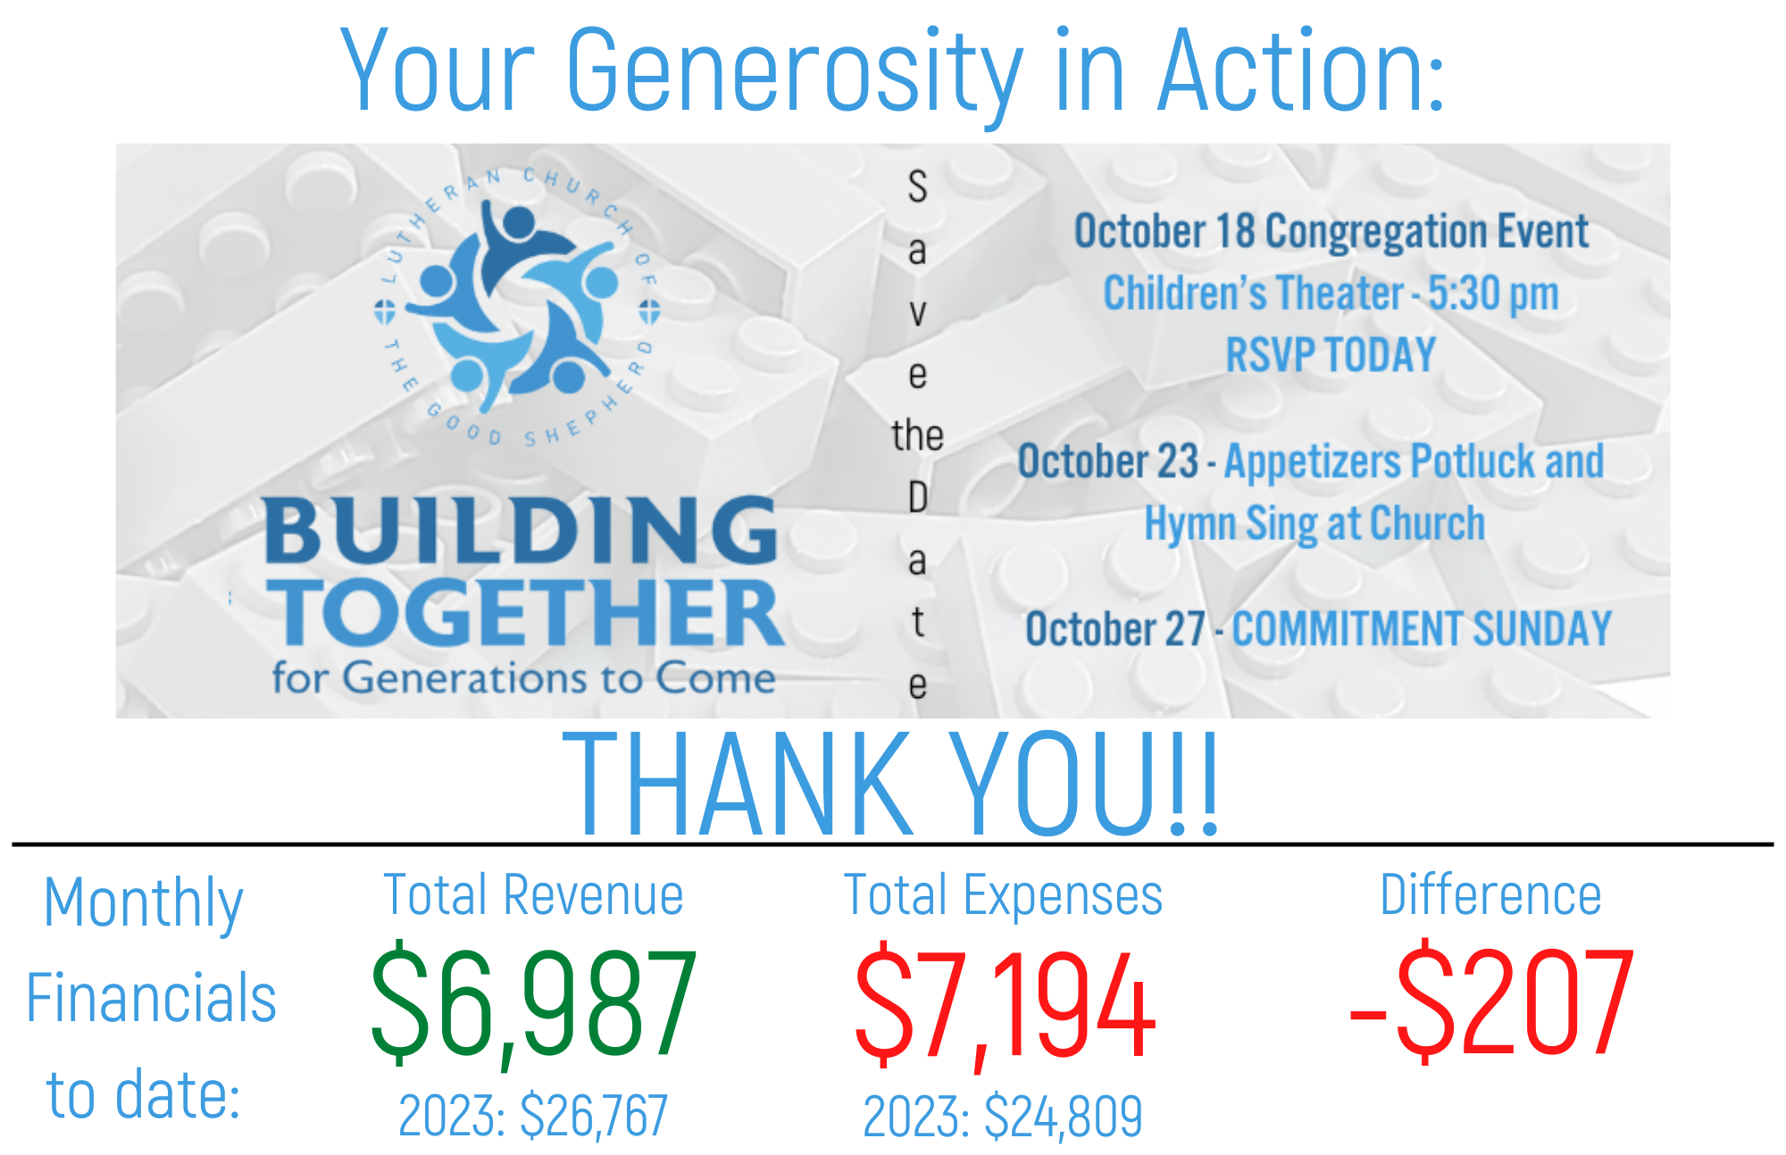**Amen.**



