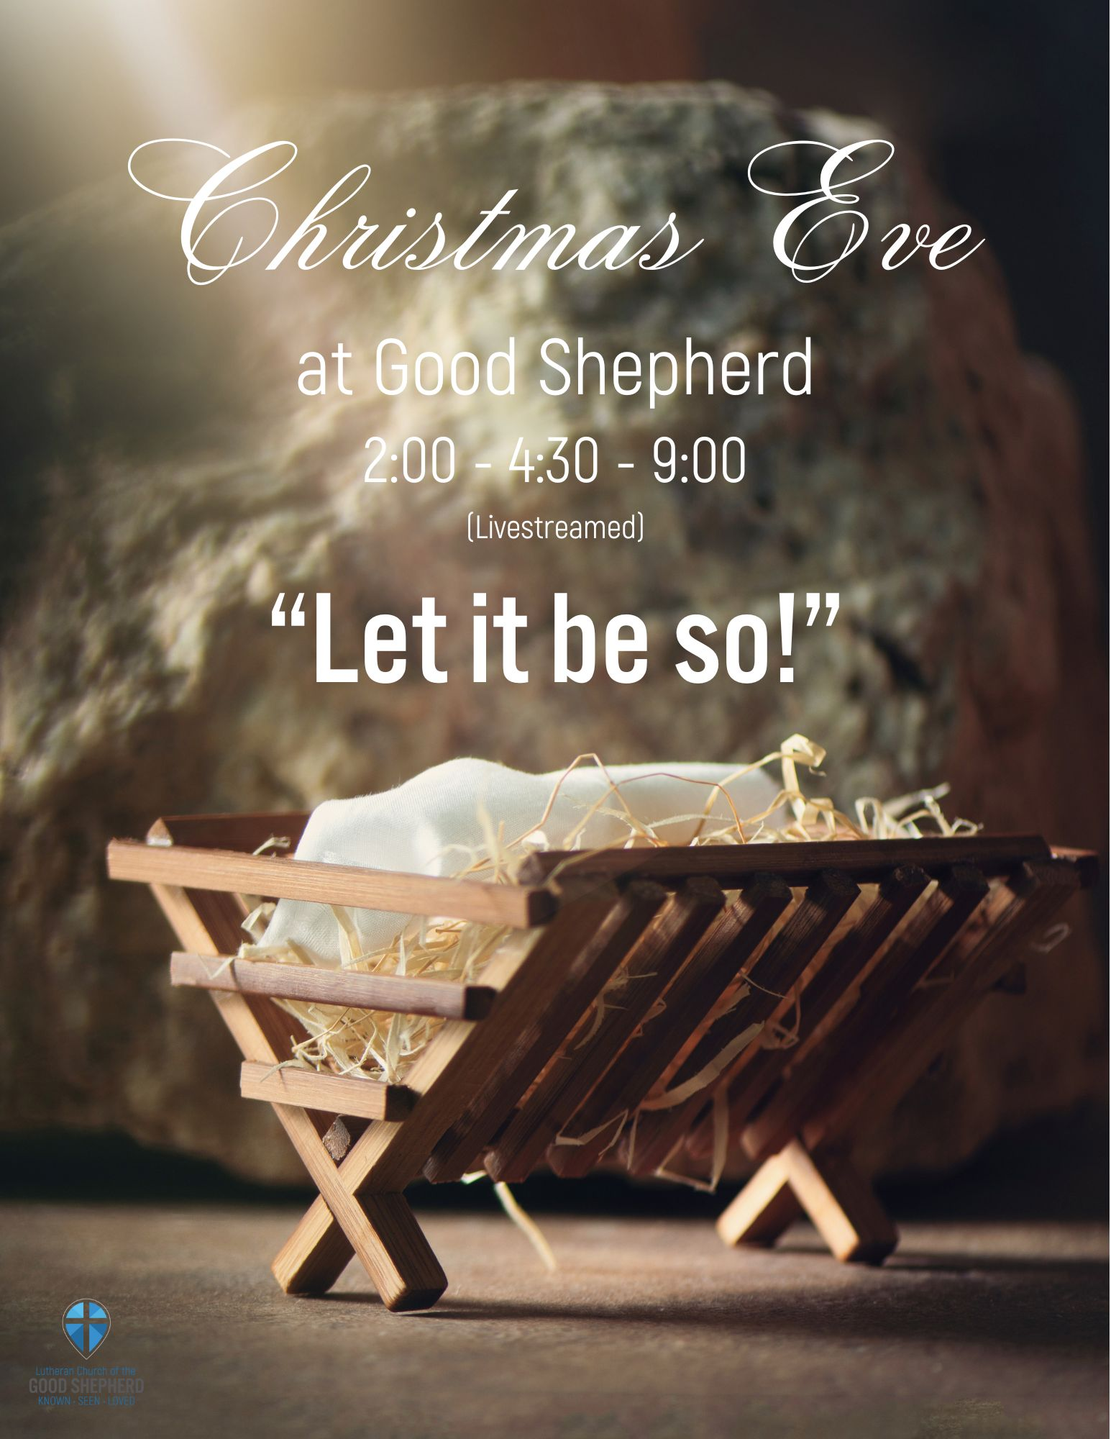

Christmas Eve
2:00, 4:30, 9:00
Prelude
Processional Hymn of Praise “O Come, All Ye Faithful” #283
Welcome and Announcements
Confession and Forgiveness
Prayer of the Day
Reading: Isaiah 9:2-7
Psalm 96 (please read responsively)
Special Music “Silent Night” Children’s Bells 4:30 p.m.
“Still, Still, Still”
Good Shepherd Bell Choir 9 p.m.
Children’s Message
Gospel Hymn “Hark! The Herald Angels Sing! #270
Gospel: Luke 2:1-20
Sermon “Let it be so”
Hymn “Joy to the World” #267
Nicene Creed
Litany and Prayers
Offering “Away in a Manger” Choir
Words of Institution
Lord’s Prayer
Communion
Distribution of the Light
Closing Prayer and Benediction “Peace, Peace” Choir
Sending Song “Silent Night” #281

We extinguish our candles knowing the light of Christ within us does not go out.
And, with that, is the call to let that light shine for all the world to see.
And so we sing…
This Little Light of Mine
This little light of mine
I’m gonna let it shine. x3
Let it shine, let it shine, let it shine!
The star shone forth from Bethlehem,
I’m gonna let it shine. x3
Let it shine, let it shine, let it shine!
The light of the world is born,
I’m gonna let it shine. x3
Let it shine, let it shine, let it shine!
P: Go in peace! Let your light shine!
C: Okay! We will! Thanks be to God!
P: And all of Good Shepherd said,
C: AMEN!
Jesus gave it to me,
I’m gonna let it shine. x3
Let it shine, let it shine, let it shine!


1120 Cedar St., Eau Claire, WI 54703-2735
Phone: 715-834-2959
Pastor Josh Toufar
www.goodshepherd-ec.org
pastorlcgsec@gmail.com
church office: lcgseauclaire@gmail.com

Poinsettias are given by the following:
Cherisma Larson, In memory of Rodger C Larson
Joe & Nancy Dennie, In memory of loved ones
Jean Wahl, In memory of husband Bill Wahl
Carol Brose, For my everlasting husband Frank
Diane Faldet, In memory of Charlie Vierbicher
Diane Faldet, In memory of Arvid Faldet
Julie Flom, In honor of my parent Ruth & Cecil West
Keith Franson, In memory of Katie Franson
Heather Garber, In memory of husband Frank Garber
Heather Garber, In honor of all family and friends
Sandra Nelson, In memory of Jim Nelson
Sarah Yenter, In memory of our son Ian Yenter
Mark & Vicki Golden, In honor of our Moms
Dave & Teri Oestreich, In memory of Annette Anderson
Marie Kumferman, In memory of my mother Carol Bollinger
Gay & Paul Gilbertson, In memory of Immanuel & Gladys Olson
Brad & Emily Barth and Family, In memory of Brad's grandpa Harland Barth
Mavis Gardow, In memory of George Gardow and in honor of Tim, Matthew, Vicki, Kevin & Tami Gardow
Bill & Lorraine Pire, "In memory of our granddaughter Adeline Pire and our parents; Emil & Gladys Steinhaur and Betty Thurson and Sam Pire"
Matt & Laura Johnson and Family In loving memory of our parents and grandparents. We love you and miss you!
Mike and Barb Huggins, In memorial to honor our parents and grandparents
Clarice Gardow, In memory of husband Robert Gardow and in honor of her family
Roger and MaryLee Sztmoniak, In honor of our grandchildren, Tristan, Tyler and Aubrin
Roger and MaryLee Sztmoniak, In memory of our parents, Walter & Rose Szymoniak and Tony & Doris Forengo
Ann & Jim Schlegelmilch and Kay & Bill Hagedown, In memory of our loved ones
Kay & Tom Karker and Steve & Deb Bradford, In memory of Mike Bradford and Franklin Johnston
Gay & Paul Gilbertson, Wishing Christmas blessings to all from the Gilbertson families
Matt & Jodi Risen and Family, In loving memory of our grandparents Roger & Delores Peterson

Renee Eder and Angel Messman, In honor of loved ones passed and loved ones struggling

